SNACKS

🟢 BOUDIN BALLZ CREAM CHEEZE JALAPEÑO

**$3.89EA OR 2/$7**

🟢 SWAMP LOGZ 5 (AKA MOZZARELLA STICKS) **$4.99**

LETZ BOWL

🟢 =BOUDIN BOWL **$4.99**

🟢 =FAIS-DO DO BOWL **$13.49**

(FRIED CHICKEN BITEZ, BOUDIN AND SHRIMP TOPPED WITH RANCH, FIYA SAUCE AND CHEESE)

🟢 =KAJUN-EATZ BOWL **$14.99**

(KAJUNMIX TOPPED WITH CRAWFISH AND FRIED SHRIMP TOPPED WITH RANCH, FIYA SAUCE AND CHEESE)

-DEM TACOZ….$4.59EA

(SOLD INDIVIDUAL)

(+$.50EA GRILLED)

(TOPPED WITH LETTUCE, CHEESE & FIYA SAUCE)

🟢=FIYA CHICKEN TACOZ (FRIED CHICKEN BITEZ)

🟢=GULF TACOZ (FRIED SHRIMP)

🟢 =CRAWFISH TACOZ (CRAWFISH TAILS)

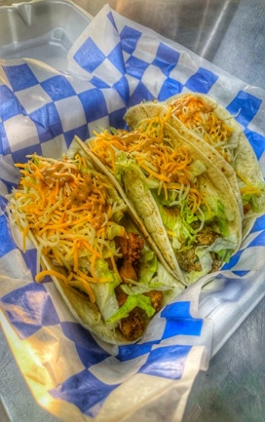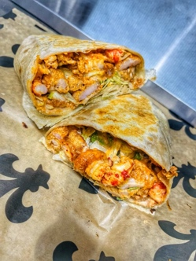

-WRAPZ W/friez

(+$1.50EA GRILLED)

(12” TORTILLA, FIYA SAUCE,RANCH, LETTUCE, CHEEZE, & PICKLEZ)

🟢 =CHICKEN **$12.99**

🟢 =SHRIMP **$13.99**

🟢 =CRAWFISH **$14.99**

-DEM LOADED FRIEZ

(+$1.49 GRILLED)

(TOPPED WITH RANCH, FIYA SAUCE &CHEEZE)

🟢 =COUYON FRIEZ (FRIED CHICKEN BITEZ)**$13.99**

🟢 =BOU-DANG FRIEZ (BOUDIN) **$14.99**

🟢 =GULF FRIEZ (FRIED SHRIMP) **$13.99**

🟢 = KAJUN FRIEZ

(BOUDIN, CHICKEN & SAUSAGE) **$14.99**

🟢 =MUDBUG FRIEZ (CRAWFISH)**$15.99**

🟢=FAIS-DO-DO FRIEZ

(FRIED CHICKEN, SHRIMP, BOUDIN) **$18.99**

🟢 =DA SWAMP FRIEZ

(CRAWFISH ETOUFFEE & CHEEZE) **$16.99**

🟢 -KAJUN-QUESADILLAZ …**$15.49**

(BOUDIN, CHICKEN, SPICY SAUSAGE W/ CHEEZE SERVED ON 2 CRISPY FLOUR TORTILLA WITH SEASONED FRIEZ)

🟢 -CRAWFISH-QUESADILLAZ**$16.99**

(GRILLED CRAWFISH W/ CHEEZE SERVED ON 2 CRISPY FLOUR TORTILLA WITH SEASONED FRIEZ )

🟢 -BOUDIN-QUESADILLAZ …**$14.99**

(BOUDIN W/ CHEEZE SERVED ON 2 CRISPY FLOUR TORTILLA WITH SEASONED FRIEZ)

🟢 FAIS-DO-DO-QUESADILLAZ**$21.99**

(12’ TORTILLA,BOUDIN,CHICKEN,SAUSAGE,SHRIMP,CRAWFISH, CHEESE & JALAPENO…SMALL FRY)

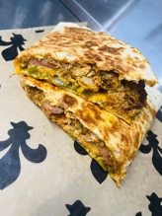

GROWN-UP GRILLED CHEEZE W/SMALL FRY

🟢=BOUDIN GRILLED CHEEZE**$12.99**

(BOUDIN WITH CHEEZE GRILLED & DAT FIYA SAUCE)

🟢=KAJUN GRILLED CHEEZE **$13.99**

MADE WITH OUR KAJUN MIX (BOUDIN, CHICKEN, SAUSAGE, FIYA SAUCE &CHEEZE)

Kidz menu

🟢 =kidz bitez$5.99

(Fried chicken bitez w/ friez)

🟢 =kidz mac $5.99

(Fried chicken bitez w/mac)

🟢 =kidz grilled cheeze $7.99

w/friez

COUYON PRODUCTS

🟢 DAT FIYA SAUCE 16OZ BOTTLE……**$6.59**

🟢 DAT FIYA DUST SEASONING……**$4.49**

🟢 DAT FIYA BATTER……**$3.99**

🟢 DAT COUYON HOT SAUCE……**$3.29**

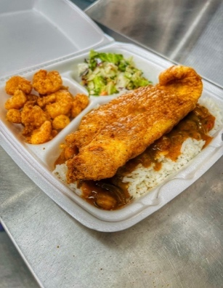

Notice: this facility may contain the following allergens: milk, eggs, fish, shellfish, dairy products, tree nuts, peanuts, potatoes, vegetables, fruits, wheat and soybeans

NONC CHANCE SPECIALITY ITEMZ

(GRILLED +$1.50)

🟢=CATFISH PLATE $15.99

(TWO FRIED CATFISH FILLETZ,FRIED SHRIMP & SMALL FRY)

🟢=CATFISH FESTIVAL $18.99

(TWO FRIED CATFISH FILLETZ TOPPED WITH CRAWFISH ETOUFFEE AND FRIED SHRIMP)

🟢=BOUDIN SAMPLER $15.99

(JALAPENO CREAM CHEEZE BOUDIN BALL, SCOOP OF BOUDIN ,BOUDIN GRILLED CHEEZE, CUP OF FIYA SAUCE)

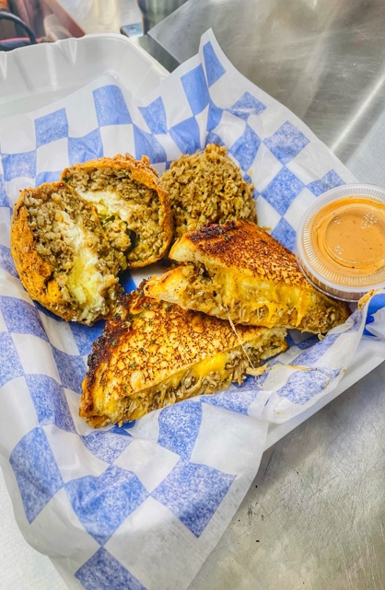

LAGNIAPPE (EXTRAZ)

🟢 DAT FIYA SAUCE **$.79**

🟢 DAT FIYA SAUCE CUP **$.99**

🟢 RANCH CUP…….**$.69**

🟢 LETTUCE **$.59**

🟢 JALAPEÑOZ **$.59**

🟢 PICKLEZ **$.59**

🟢 CHEEZE **$.99**

🟢 SUNNY SIDE UP EGG **$1.29**

🟢 **XTRA CHICKEN, SHRIMP,**

**BOUDIN, KAJUNMIX, FISH $3.99EA**

**CRAWFISH $4.29 ETOUFFEE $5.99**

🟢 SIDE OF SEASONED FRIEZ **SM$3.99/LG$4.79**